
PinJig FrameSystem Rules –
Structural Manufacturing

PinJig FrameSystem Rules.doc
Status: Draft
Author: StructMfg-Team

SM3D Concept Design Document.
January 9 , 2012
© 2012 Intergraph Corporation. All rights reserved.
The content of this document is proprietary work of Intergraph Corporation, or relevant third parties, and is protected by copyright law and international treaty. Any use, duplication, distribution or disclosure of such, other than as specified herein, is unauthorized and in violation of applicable copyright law and international treaty. All rights in content or materials bearing copyright notice or other attribution of third party rights are reserved to the relevant third party. United States Government license rights are limited to those mandatory rights identified in DFARS 252.227-7015(b).
Intergraph may make improvements and/or changes in the products and/or the programs described in this publication at any time without notice.
Any content or materials supplied hereunder are provided "as is," without warranty of any kind, either expressed or implied, including, but not limited to, any implied warranties of merchantability, fitness for a particular purpose, or against infringement. In no event shall Intergraph be liable for any damages arising out of, or in connection with the downloading, viewing, use, duplication, distribution or disclosure of any content or material published by Intergraph, including but not limited to any direct, indirect, incidental, special, punitive or consequential damages, or loss or corruption of data.
Some jurisdictions do not allow the exclusions or limitations set forth above, so the above may not apply to you. The exclusions or limitations shall apply in all jurisdictions to the maximum extent allowed by law.

Intergraph Corporation
170 Graphics Drive
Madison, AL 35758
Phone: +1.256.730.2000
Toll Free USA: +1.800.345.4856
Fax: +256.730.2048

Contents
Introduction 2
References 2
Definitions 2
Bulkload 3
Rule Framework and Implementation 3

Revision # | Date Revised | Revised By | Description
0.1 | 09 -Jan- 2012 | Manasa Jaisetty | Initial Version.

Introduction
The purpose of this document is to describe the framework of PinJig frame system rule.

References

Definitions

Bulkload
- The framesystem rules are avialble in “MfgFrameSystem” sheet of “StructMfgSettings.xls” workbook. User can modify the prog-id for “CPinJig_FrameSystem” rule.
Location: “\ShipCatalogData\BulkLoad\DataFiles\StructManufacturing\StructMfgSettings.xls”

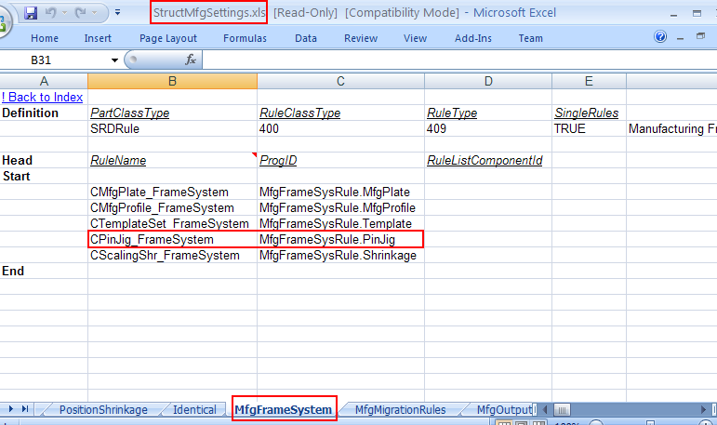

Rule Framework and Implementation

The PinJig frame system rule is delivered at the below location:
- “\SharedContent\Src\StructManufacturing\Rules\PinJig\FrameSystem”

The purpose of this rule is to specify the eligible frame systems that can be set on the Pinjig.

WORKFLOW:

- Client calls the frame system rule to populate the eligible frame systems for the Pinjig.

The framesystem rule class(PinJig.cls) implements “IJMfgRuleForFrameSystem” interface.
Following methods are exposed on IJMfgRuleForFrameSystem interface:
1. GetFrameSystemForMfgEntity
Signature: Private Function IJMfgRuleForFrameSystem_GetFrameSystemForMfgEntity(ByVal pEntityDsp As Object) As IMSCoreCollections.IJElements
Input: PinJig object
Output: Collection of eligible frame systems that can be set on the Pinjig.
Description: The current implementation returns the all the frame systems in the range of the PinJig object.

